What is a PSU? (Power Supply Unit — Explained In-Depth)
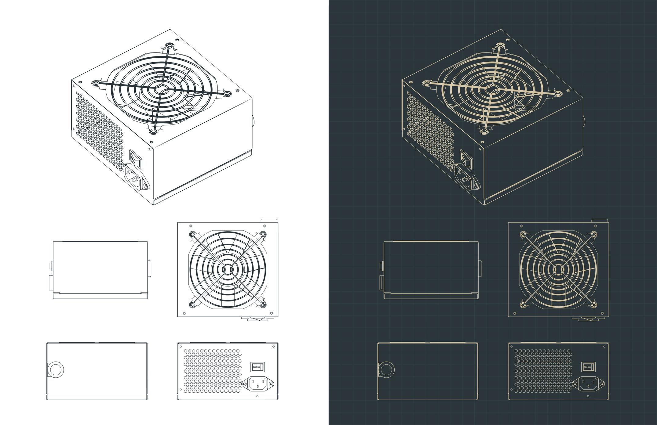
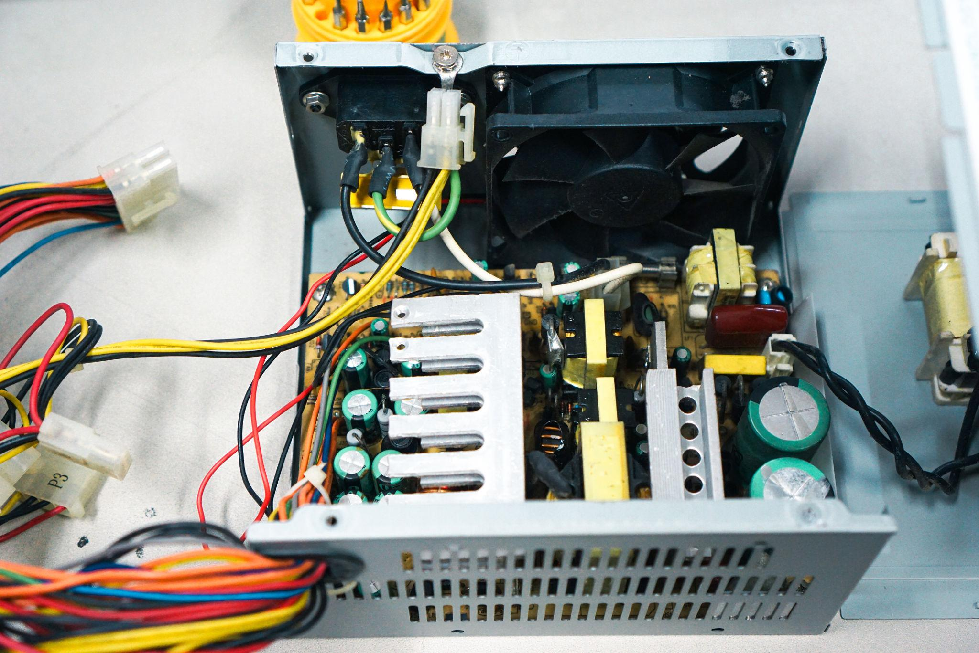
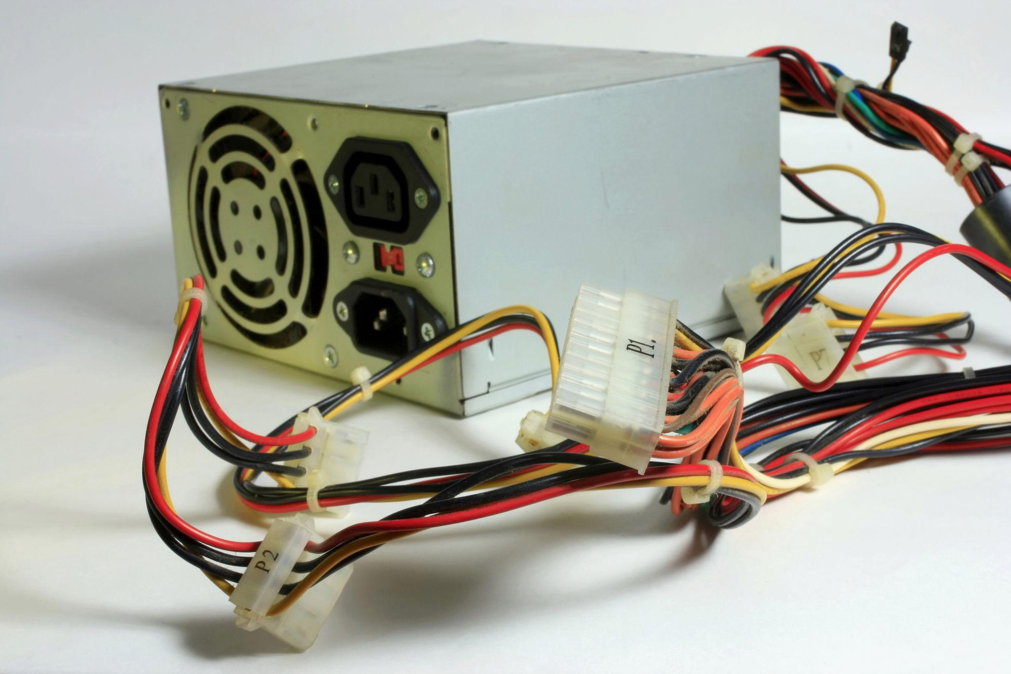
PSU = Power Supply Unit
The PSU is the component that feeds life to your PC.
It does three critical jobs:
- 🔄 Converts AC → DC
  - Wall socket gives AC power
  - PC components need DC power
  - PSU converts safely and precisely
- ⚡ Supplies clean & stable power
  - CPU, GPU, RAM need exact voltages
  - PSU smooths fluctuations
  - Prevents spikes & drops
- 🛡️ Protects components
  - Over-voltage protection (OVP)
  - Over-current protection (OCP)
  - Short-circuit protection (SCP)
  - Cheap PSU = risk of killing components
⚠️ Most ignored, most important part of a PC

⚡ PSU Wattage Reality (Big Myth Buster)
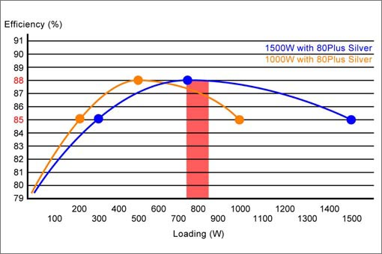
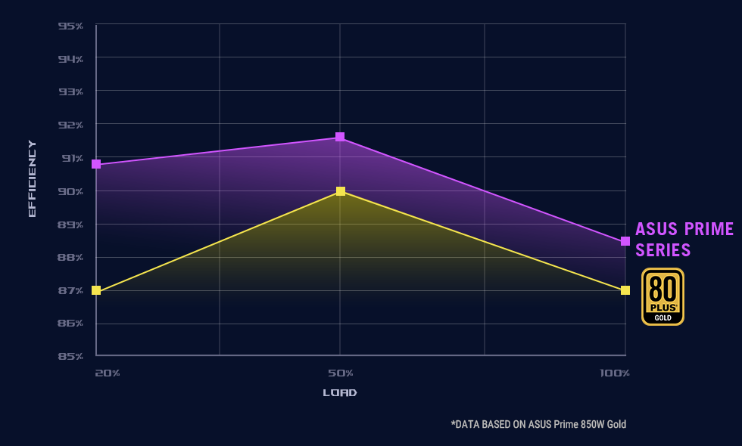
Wattage = Maximum Output
- 650W PSU → can supply up to 650W
- It does NOT push power forcefully
PC Draws Only What It Needs
Example:
- PSU = 750W
- PC load = 320W
👉 PSU supplies only 320W
❌ Higher Watt ≠ Higher Electricity Bill
Power bill depends on:
- Actual usage
- Time used
Not PSU rating.
📌 Think of PSU like a water tank, not a pump.

🧮 How Much Wattage Do You Actually Need?
System Type | Recommended PSU
Office PC | 450–550W
Entry GPU | 550–650W
Mid GPU | 650–750W
High-end GPU | 750–850W+
👉 Always keep 30% headroom.

🏅 PSU Quality & 80+ Ratings (VERY Important)
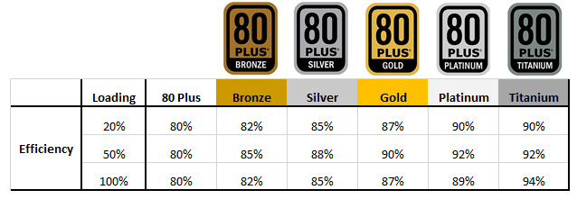
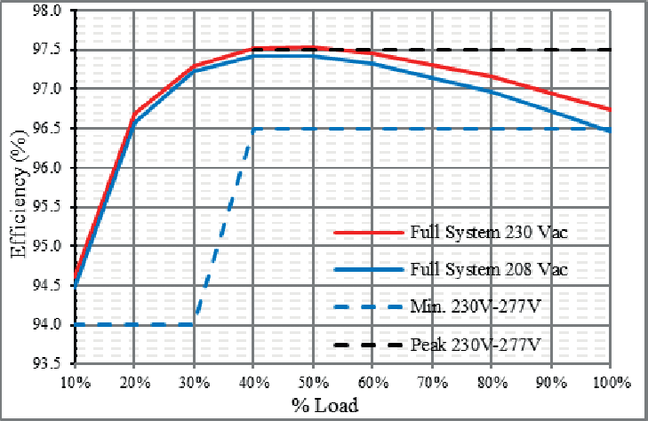
What is 80+ Rating?
It measures efficiency, not power.
Efficiency =
How much wall power becomes usable PC power

🔋 Common Ratings
Rating | Efficiency | Meaning
Bronze | ~82–85% | Good
Gold | ~87–90% | Best value
Platinum | ~90–92% | Premium
Titanium | 94%+ | Enterprise

Why Efficiency Matters
Higher efficiency:
- Less heat
- Quieter fan
- Longer PSU life
- More stable voltage
- Lower stress on components
📌 Gold is the sweet spot for most users.

🔥 Cheap PSU vs Good PSU (Reality)
Cheap PSU | Good PSU
Fake wattage | True rated
Poor protection | Full protection
Voltage spikes | Stable output
Can damage PC | Protects PC
❌ Never cheap out on PSU

🔌 PSU Cables Explained (Know This!)
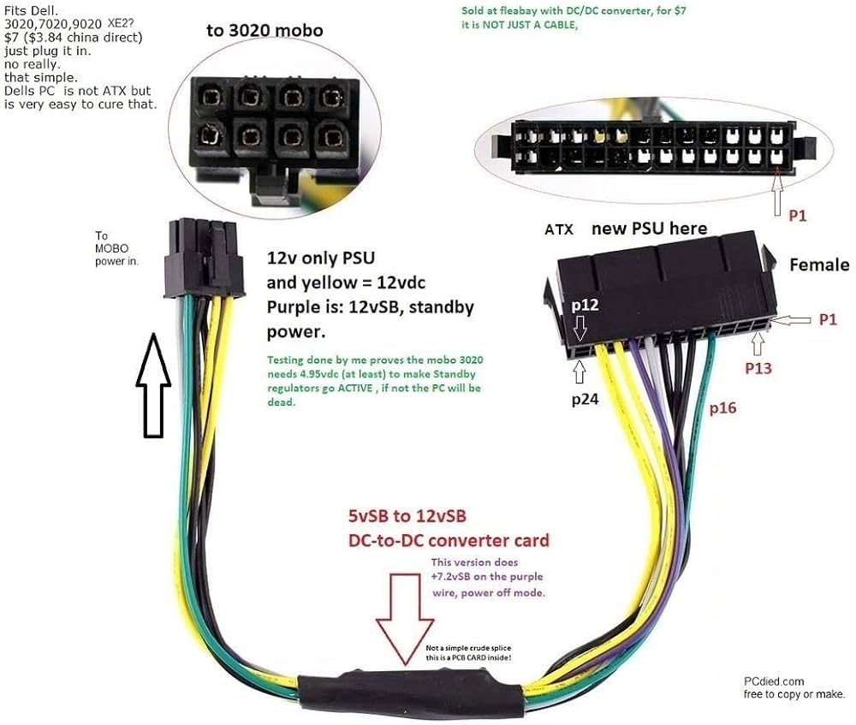
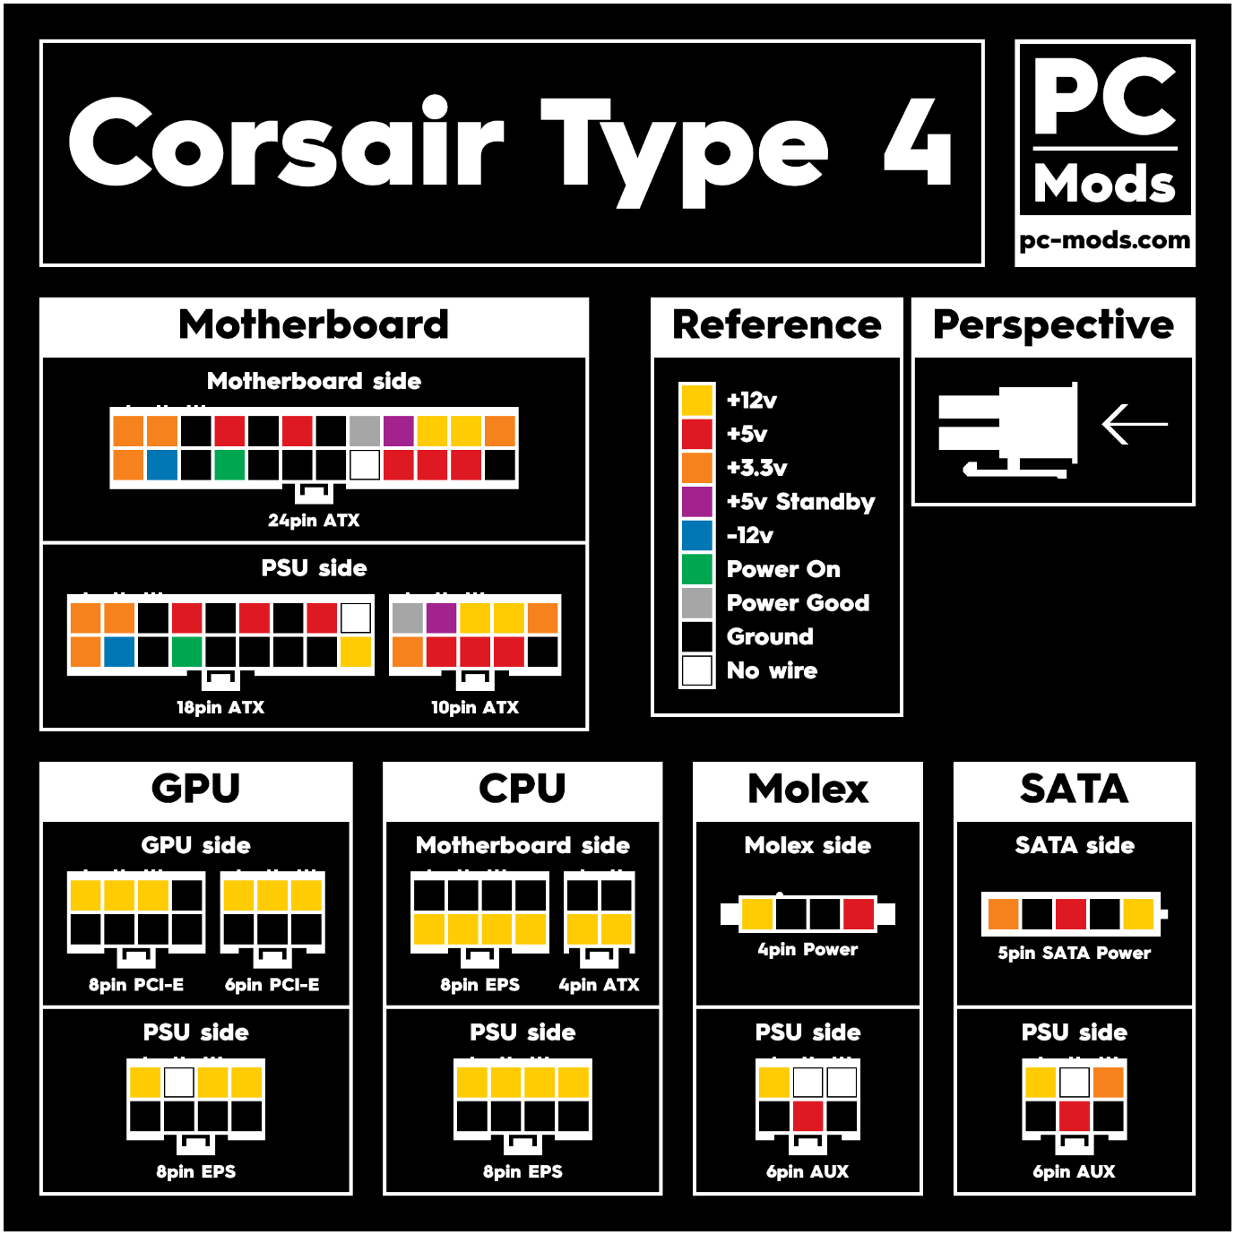
1️⃣ 24-Pin ATX → Motherboard
- Main power line
- Mandatory for boot

2️⃣ 8-Pin (4+4) → CPU
- Powers CPU VRMs
- High current
- Sometimes 8+4 on high-end boards

3️⃣ PCIe (6+2 Pin) → GPU
- Supplies power to graphics card
- GPUs may need:
  - 1 cable
  - 2 cables
  - New 12VHPWR connector

4️⃣ SATA Power → Storage
- SSDs
- HDDs
- RGB hubs
- Accessories

⚠️ CRITICAL WARNING: Never Mix PSU Cables
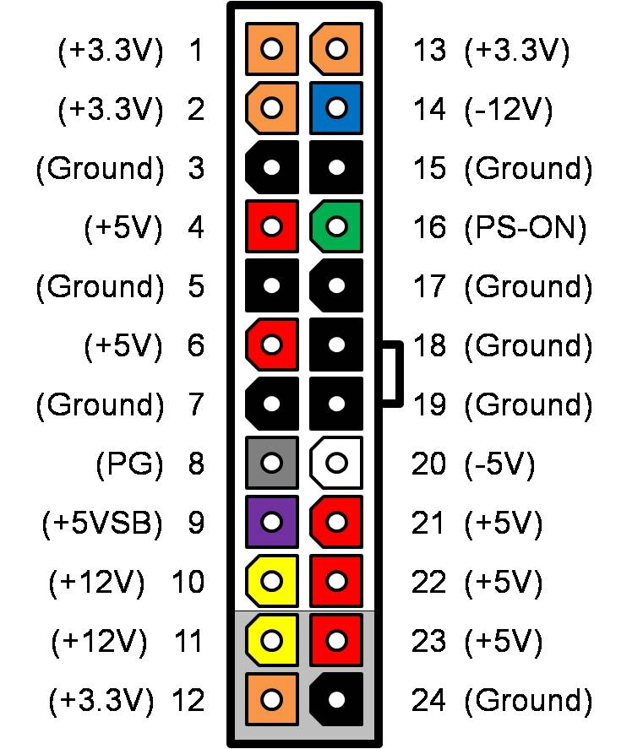
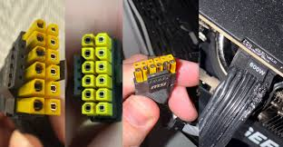
❌ Even same brand
❌ Even same wattage
❌ Even same model series
Cable pinouts differ internally
Mixing cables can:
- Instantly kill SSD
- Burn motherboard
- Damage GPU
✔️ Use ONLY cables that came with that PSU

🧩 Modular vs Non-Modular PSU
Type | Description
Non-modular | All cables fixed
Semi-modular | Some fixed, some detachable
Fully modular | All cables detachable
📌 Fully modular:
- Cleaner build
- Better airflow
- Easier upgrades

❄️ PSU Cooling & Orientation
- PSU has its own fan
- Mount fan:
  - Downward (with bottom vent)
  - Upward (no bottom vent)
Wrong orientation → overheating.

🧠 Why PSU Affects Performance (Indirectly)
- Weak PSU → voltage drops
- CPU/GPU throttle to protect themselves
- Random crashes under load
- System instability
Same PC
Different PSU
→ Different real-world stability

🧪 Real Example
High-end GPU + cheap PSU:
- PC boots
- Crashes during load
- GPU throttles
Same system + good Gold PSU:
- Stable
- Sustained boost
- Longer component life

🎯 Buying Checklist (Easy Rule)
✅ Enough wattage + headroom
✅ 80+ Gold minimum
✅ Reputed brand & warranty
✅ Correct GPU connectors
✅ Good reviews on voltage stability

🏁 Final Truth
- PSU does NOT increase FPS
- PSU decides system safety
- PSU decides long-term reliability
- PSU is the silent protector

🧠 One-Line Summary
CPU is the brain, GPU is the muscle,
PSU is the heart — weak heart, whole system fails.

